YEAR 2017

April 12, 2017
Shri B C Tripathi, CMD, GAIL receives the fastest growing Maharatna PSU Award.
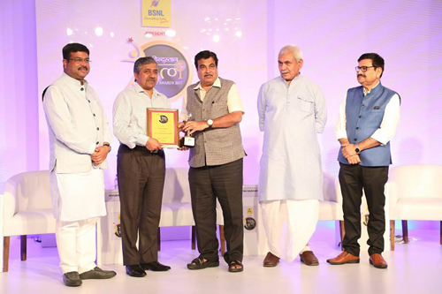
Shri B C Tripathi, CMD, GAIL received the fastest growing Maharatna PSU Award from Shri Nitin Gadkari,

YEAR 2016
GAIL CSR project wins Prestigious CII-National Water Awards for Excellence in Water Management-2016
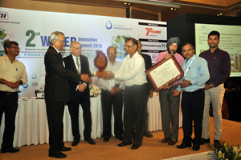
GAIL won the Prestigious CII-National Water Awards for Excellence in Water Management-2016 in “out of fence Category” for outstanding work in Watershed management & development under CSR project: Jaldhar in Jhabua District of Madhya Pradesh.

September 27, 2016

YEAR 2014

May 29, 2014
GAIL declared the top Indian company in the ‘Gas-Processing, Distribution and Marketing’ Sector for the Dun & Bradstreet Corporate Awards 2014
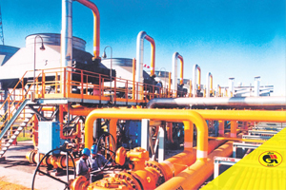
GAIL (India) Limited was awarded the top Indian company in the Gas-Processing, Distribution and Marketing Sector for the Dun & Bradstreet Corporate Awards 2014.

GAIL adjudged ‘Company of the Year’ for Project Management for Dabhol – Bengaluru pipeline
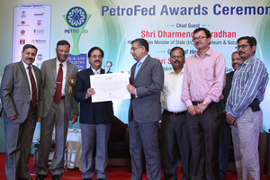
GAIL (India) Limited was adjudged ‘Company of the Year’ in the Project Management category for its Dabhol – Bengaluru natural gas pipeline project at the Petroleum Federation of India (PetroFed) Oil & Gas Industry Awards 2013.

September 8, 2014

YEAR 2013

December 20, 2013
GAIL DBPL project receives Platts Premier Project Construction Award for 2013
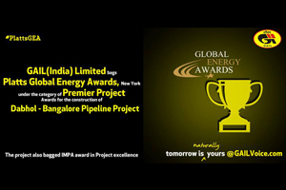
The Dabhol-Bengaluru pipeline was dedicated to the nation by the Hon´ble Prime Minister of India during the 8th Asia Gas Partnership Summit 2013. The Rs. 4508 crore, 1000 Km long High pressure Dabhol-Bengaluru Gas Pipeline Project

GAIL C&MD, Shri B C Tripathi, conferred the prestigious ‘Best LNG Executive Global Award’ for 2013 at CWC´s 14th World LNG Summit being held at Paris
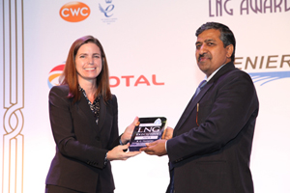
GAIL (India) Limited Chairman and Managing Director, Shri B C Tripathi, was conferred the prestigious ‘Best LNG Executive Global Award’ for 2013 at CWC´s 14th World LNG Summit being held at Paris. More Details

November 20, 2013

June 28, 2013
GAIL receives Oil & Gas Pipeline Transportation Company of the year, besides Project Management (Rs 500 crore to Rs 2,000 crore category) of the year, the Environmental Sustainability of the year category in the Petrofed Awards 2012 and Woman Executive of the Year in Oil & Gas Industry
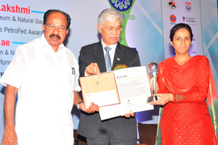
GAIL (India) Limited received Oil & Gas Pipeline Transportation Company of the year, besides Project Management (Rs 500 crore to Rs 2,000 crore category) of the year and the Environmental Sustainability of the year

YEAR 2011
Platts Global Energy Award, 2011 for ‘World´s No. 1 Company in Downstream Operations
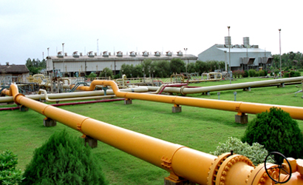
GAIL (India) Limited, India´s leading natural gas company received top honors as the “World´s No. 1 company in Downstream Operation” for 2011 at the Platts Global Energy Awards held at New York on December 1, 2011. More Details

December 2, 2011

YEAR 2010

December 15, 2010
Prime Minister´s ‘MoU Excellence Award’ for the year 2008-09
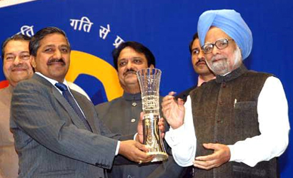
Prime Minister´s ‘MoU Excellence Award’ for the year 2008-09

Ranked as Asia´s No.1 gas utilities company in the Platts Global Ranking of Energy Companies
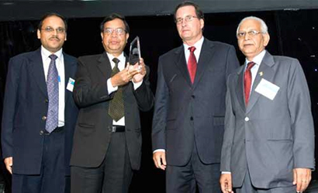
In the 2010 rankings, GAIL moved past heavyweights like Tokyo Gas, Osaka Gas Co., Hong Kong & China Gas, Korea Gas Corp to be ranked no.1 company among gas utilities in Asia More Details

November 6, 2010

YEAR 2007

April 10, 2007
Scope Meritorious Award for Corporate Governance 2007-2008
